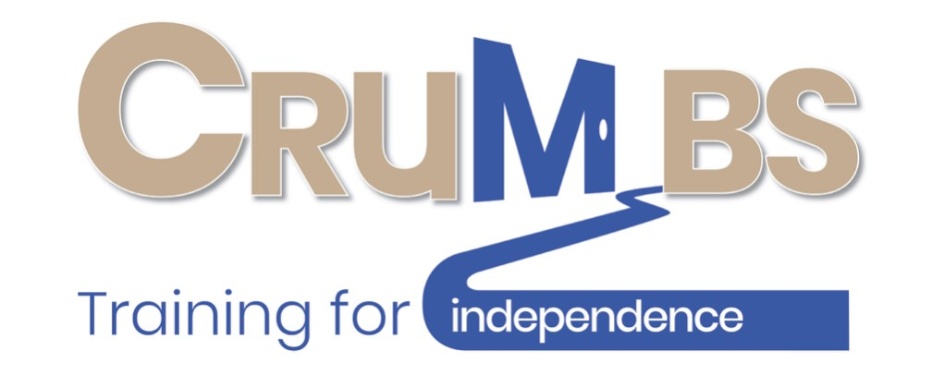
Contract for Self-Funding Trainees
This contract is between NAME OF COMPANY/PERSON PROVIDING THE FUNDING and the Crumbs Project for the training services to be provided for: NAME OF TRAINEE
Crumbs will support and train NAME OF TRAINEE in Catering and NAME OF TRAINEE will need to work in both kitchen and bakery for the purposes of the training.
NAME OF TRAINEE will attend an induction which will cover basic Health & Safety, Fire Alarm Procedures and Food Safety rules. Trainees are also asked to sign media consent forms, a Computer Policy and will be asked to read the Crumbs Code of Conduct. Crumbs do not tolerate any form of bullying, harassment or discrimination and such behaviour can result in the trainee being asked to leave.
The Crumbs training is geared towards employment and as such the environment is employment driven and we work towards employability skills. As in all employment we expect our trainees to keep good timekeeping, phone in when they are sick or unfit for work, book holidays in advance and respect both their peers and management alike. We expect trainees and their external support to acknowledge and agree to our terms and conditions.
Part of the criteria for NAME OF TRAINEE attending Crumbs is for a representative/key worker/family member are available every 3 months to attend a review where the trainee’s progress will be discussed, and goals set for the following 3 months.
NAME OF TRAINEE start date is START DATE and NAME OF TRAINEE is expected to attend every DAYS OF SHIFTS. Their shift times are TIMES OF SHIFTS. These times may be changed in the future to suit the business needs but not without prior notice. The cost per hour will be £10.00; invoices will be sent out on a monthly basis.
Charges are made for every session the trainee attends or is due to attend. This covers all absences for either holidays, sickness, or no shows.
There will be no charges for when Crumbs is closed i.e. Bank Holidays, public holidays and between Christmas and New Year. (Please note Crumbs does not close for any other holidays, once again we are a working environment).
Should NAME OF TRAINEE or her support feel the placement should be terminated we request one month’s notice.
Please confirm the information needed for invoice purposes below: -
Invoice to be sent to: NAME / ORGANISATION
Any reference:
Any cheques should be made payable to THE CRUMBS PROJECT and if paying by BACS our bank account details are: CAF bank Account: 00023501 Sort code: 40-52-40
We would ask invoices are paid within 28 DAYS.
Please provide contact details for emergency purposes: -
Name: Relationship to trainee:
Telephone No:

I have read and understand the terms and conditions for NAME OF TRAINEE attending the Crumbs Project and the commitment required to make the placement successful.
Signed:
Name:
Company: Position within company:
Date:

Signed on behalf of The Crumbs Project:
Signature:
Name: Position within company:
Date:
The Crumbs Project Registered Charity No 1151926
Hibberd Court, 20a Hibberd Way, Bournemouth BH10 4EP
Phone: 01202 519320 email: training@crumbs.org.uk www.crumbs.org.uk

