Crumbs COVID-19 Contingency/Risk Planning
‘What If’ Scenarios
Date: Tuesday, 6 April 2021
Ser | Scenario | Trigger | Immediate Response | Follow Up actions | Notification | Potential Mitigation | Impact
1 | National Lockdown | Government announcement | - Close Centre for all but essential staff to maintain food service for residents and the vulnerable  - Stop professional training for trainees | - Advise staff of requirements/ Send staff home /revise and implement new rota  - Maintain online training with trainees in accordance with schedules | - Board Members  - Aster Housing  - BCP  - Clients  - Trainees/ Care workers etc | - Ensure stock of frozen meals for residents  - Online training activities enhanced to mitigate impact on trainees  - Trainers/staff to support training | HIGH
2 | Local Lockdown | BCP or Public Health Dorset announcements | - Close Centre for all but essential staff to maintain food service for residents and the vulnerable  - Stop professional training for trainees | - Advise staff of requirements/ Send staff home /revise and implement new rota  - Maintain online training with trainees in accordance with schedules | - Board Members  - Aster Housing  - BCP  - Clients  - Trainees/ Care workers etc | - Staff shift teams in operational ‘bubbles’ to minimise contacts and maintain service  - Trainees in shift and training 1-1 bubbles to reduce contact and risk  - Management team to alternate shift patterns and working from home to minimise contacts and maintain service | HIGH
3 | Hibberd Court records infection in residents | Notification from Aster Housing/BCP/PH Dorset | - Follow advice from PH Dorset  - Option 1 - Temporary closure  - Option 2 - Full closure | - Instigate deep clean protocols - to follow Aster procedures  - Provide reduced food service post deep clean if allowed by PHD/BCP  - Suspend professional training as advised by PH Dorset/BCP  - Resume online lockdown training | - Board Members  - BCP - Social care  - Clients - if full closure  - Trainees/ Care workers etc | - Ensure stock of frozen meals for residents  - Online training activities enhanced to mitigate impact on trainees | HIGH
4 | Confirmed case of Covid-19 - Staff/Volunteer/Trainee | Notification from: NHS Test & Trace/BCP/ PH Dorset or individual | - Contact PH Dorset PHT  - Instigate case details (Annex A)  - Temporary closure | - Instigate deep clean protocols  - Suspend professional training as advised by PH Dorset/BCP  - Online training to continue | - Board Members  - Aster Housing  - BCP - Social care  - Trainees/ Care workers etc | - Ensure stock of frozen meals for residents  - Online training activities enhanced to mitigate impact on trainees | MED
4.1 | Close contacts identified | - Within 2 metres for more than 15 minutes  - Within 1 metre for 1 minute  - Travelled in a small vehicle  - Contacted by NHS Test & Trace | - Contacts are to Self -isolate for 10 days  - Crumbs inform co workers of the case without naming the individual - may be required to self isolate if notified by Trace & Test  - Contacts to book a test if symptoms occur  - Temporary closure if advised by PHT | - Instigate deep clean protocols  - Suspend professional training as advised by PH Dorset/BCP  - Reschedule staff to maintain services if possible - will depend on number of staff self isolating | - Board Members  - Aster Housing  - BCP - Social care (if appropriate)  - Trainees/ Care workers etc | - Staff shift teams to minimise contacts and maintain service  - Management team to alternate working from home to minimise contacts and maintain service | MED
4.2 | Suspected case of Covid-19 - Staff/Volunteer/Trainee | - Individual reports potential symptoms (See Flowchart at Annex B) | - Advised to go home  - Individual to self isolate  - Book a test | - If test is positive follow actions for Scenario 4.1 as above.  - If negative undertake individual risk assessment prior to return to work  - If inconclusive complete 10 days self isolation | - Board Members  - Aster Housing  - BCP - Social care if appropriate  - Trainees/ Care workers etc | - Staff shift teams to minimise contacts and maintain service  - Management team to alternate working from home to minimise contacts and maintain service | MED
5 | Close contact of Staff/Volunteer/Trainee tests positive | - Individual notified by NHS Test & Trace to self isolate  - Are a member of the same household as someone who has symptoms or tested positive | - Support individual through self isolation | - Inform co workers  - Ensure they receive the appropriate pay  - Reschedule staff to maintain services if possible - will depend on number of staff self isolating | - Board Members  - Aster Housing  - Trainees/ Care workers etc | - All above measures already in place  - Inform all staff of the measures to be taken  - Review and re-emphasise all Covid-19 mitigation and control measures | MED

Annex A
Crumbs COVID-19 Contingency/Risk Planning
Notification Case Details

Location: Crumbs - Hibberd Court Hibberd Way Bournemouth BH10 4 - Local Authority: Bournemouth, Christchurch and Poole Council
Contact Details: 01202 519320 info@crumbs.org.uk Date of Notification:
Type of Premises: Food Production and Training - within sheltered accommodation

Incident/ Event | Individual(s) affected | When last on Premises | Role | Known Links to Covid-19 cases | Individuals with whom they had close contact | Actions taken | Notifications

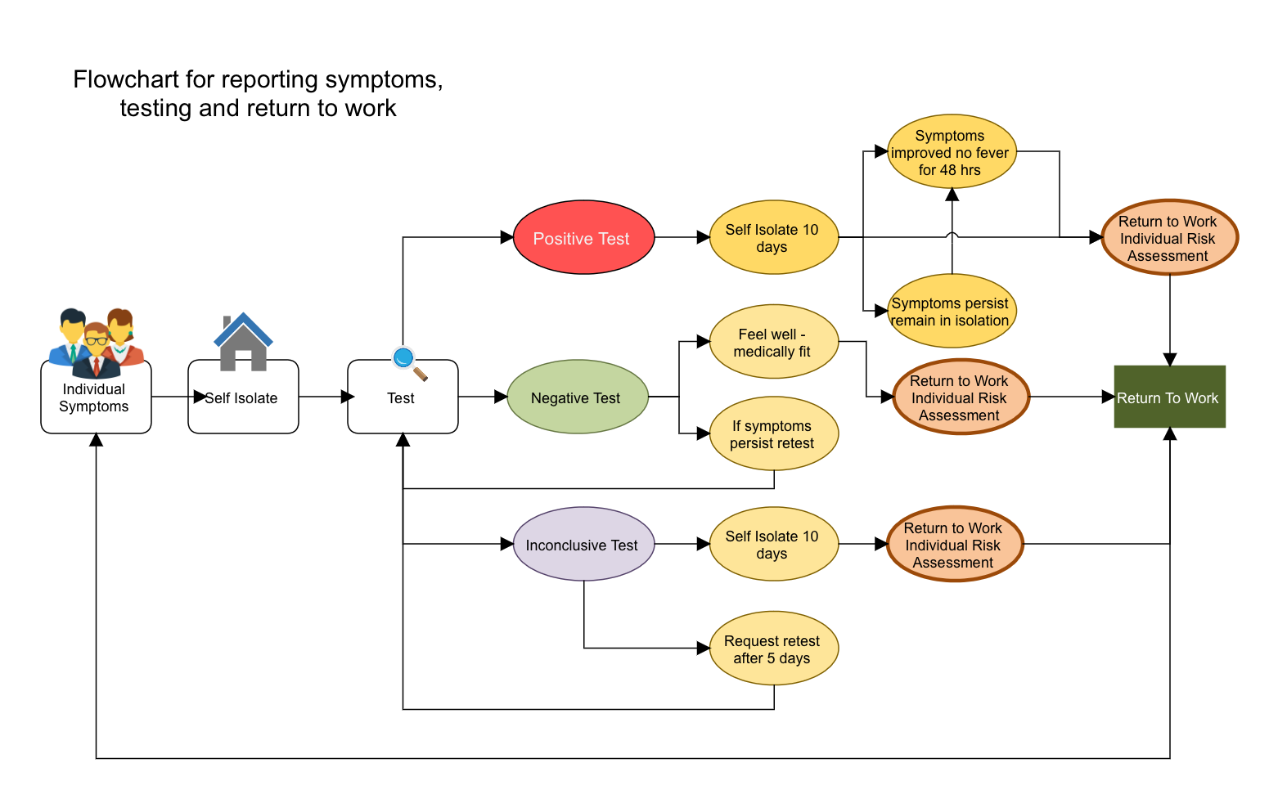
Annex B

Reference Documents

- Guidance : NHS Test and Trace service in the workplace
- COVID-19: management of staff and exposed patients or residents in health and social care settings
- Coronavirus (COVID-19): adult social care guidance
- Maintaining records of staff, customers and visitors to support NHS Test and Trace
- COVID-19: Guidance for the safe use of multi-purpose community facilities
- Stay at home: guidance for households with possible or confirmed coronavirus (COVID-19) infection

