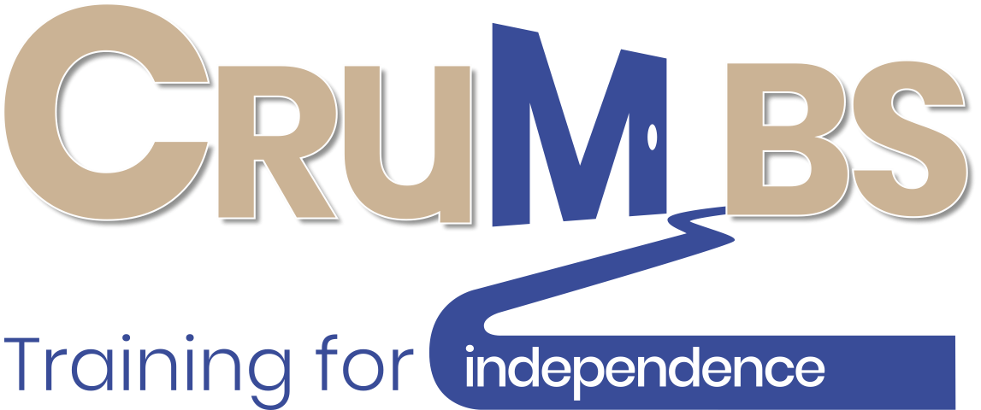
Covid -19 Training Protocols
COVID GUIDELINES
July 2020 ⎸
1
2
3
4
5
6
7

Pathway to Reopening
Step 1
All documentation developed, risk assessments carried out and mitigation measures in place.

Step 2
Crumbs Centre - operational protocols developed to take into account the physical distancing requirements, safe working practices, shift systems and revised working practices.

Step 3
Staff and volunteer briefings and discussions on returning to work arrangements including risk assessments and completing Covid -19 training. Staff and volunteers sign Return to Work forms.

Step 4
Advice sought from BCP on any special measures or guidelines relating to trainees, given the vulnerable nature of those trainees.

Step 5
Training video for trainees on the differences they will see on returning to training. Trainees complete online Covid-19 training. Trainees contacted, individual discussions and commitment including key workers on returning to professional training at the Centre.

Step 6
All documentation and systems in place and verified. Approval by the Board on reopening schedule.

Step 7
Gradual phased reintroduction of trainees

Contents

Introduction 4
Background 5
Training Protocols 6

Introduction

This guide highlights the actions that have been taken to ensure that the Crumbs Centre is a Covid-19 Secure Training Environment for all of the Crumbs Beneficiaries.
The training protocols have been developed based on the relevant guidelines for hospitality businesses and should be read in conjunction with the Crumbs Reopening Guide that provides the details of the health and safety and mitigation measure that are in place.

Professor Peter A Jones MBE
Chair

Background
All staff and trainees will follow the guidance provided in the following documents:
- Working safely during the coronavirus outbreak - short guide HSE publication 05/2020
- Keeping workers and customers safe during COVID-19 in restaurants, pubs, bars and takeaway services. COVID-19 secure guidance for employers, employees and the self- employed. Government Publication published 23 June 2020
- Risk control, assessment and management, Crumbs Publication, published 04/2020
- Crumbs Returning to Work Business Adjustments Post Covid -19 published 05/2020
- Crumbs Covid -19 Risk Assessment 06/2020
- Crumbs Covid -19 Covid -19 Risk Mitigation Operational Statement
- Helping day centres to unlock lockdown, part 1/2 July 2020
The trainees professional practical training that took place within the centre, during the period of the lockdown, had to be suspended. In view of the vulnerable nature of the trainees and the need to maintain a learning engagement a wide range of online tools have been used to maintain learning and encourage engagement. This online and digital engagement and learning has been particularly successful and will continue when the Centre is able to reopen. The more knowledge based aspects of the training will be delivered online not therefore requiring trainees physical attendance at the Centre for those elements. The use of Zoom as one of the digital tools allows for small group work, employability skills and one to one mentoring sessions.
This approach is illustrated in Annex A
The professional practical training essential as part of the professionally recognised training program has been reorganised and modified in view of the revised health and safety measures, the building capacity and the physical distancing requirements.
This has led to revised standardised training sessions of 4-hour shift bubbles limiting the number of trainees who can operate safely within each discrete area in each shift. This pattern will allow trainees to complete the training programme but will inevitably lead to an extension of the time required.

Training Protocols
The training protocols being adopted are:
- All trainees will be given the opportunity to complete the appropriate level of certification for their registered training programme.
- All trainees will receive their contracted "learning hours”.
- The training delivery will be split into professional practical sessions and digitally based online sessions including employability skills.
- Trainees attendance at the centre will be limited to their professional practical sessions.
- Individuals trainees programmes will reflect their current levels of progression and attainment.
- Trainees will be in the professional practical sessions in "shift bubbles” with staggered start times, break times and departure times to ensure there is no potential for crossover or cross infection with other “bubbles".
- The standardised ‘shift bubbles’ are four hour sessions with breaks between for trainees to depart/arrive at staggered times.
- The trainees ‘bubbles’ will not exceed six trainees per shift, allocated to the different operational ares as indicated in a draft shift rota as shown at Annex B
- Strict physical distancing and capacity measures are in place and trainees will be monitored throughout their sessions to ensure these are adhered to.
- Trainees will have completed a certificated COVID-19 return to work induction programme and received individual mentoring sessions on what to expect on returning to the Centre. This includes watching the return to operation video and answering the appropriate questions during those discussions.
- Discussions will be held with the trainees carers/key worker/support worker/parents to explain the situation and to understand if there are any health or other issues that may prevent the trainee from returning to training.
- All trainees will be required to sign, along with their carer, a return to training form that confirms that they have received the induction training, watched the video and wish to return to formal training.

