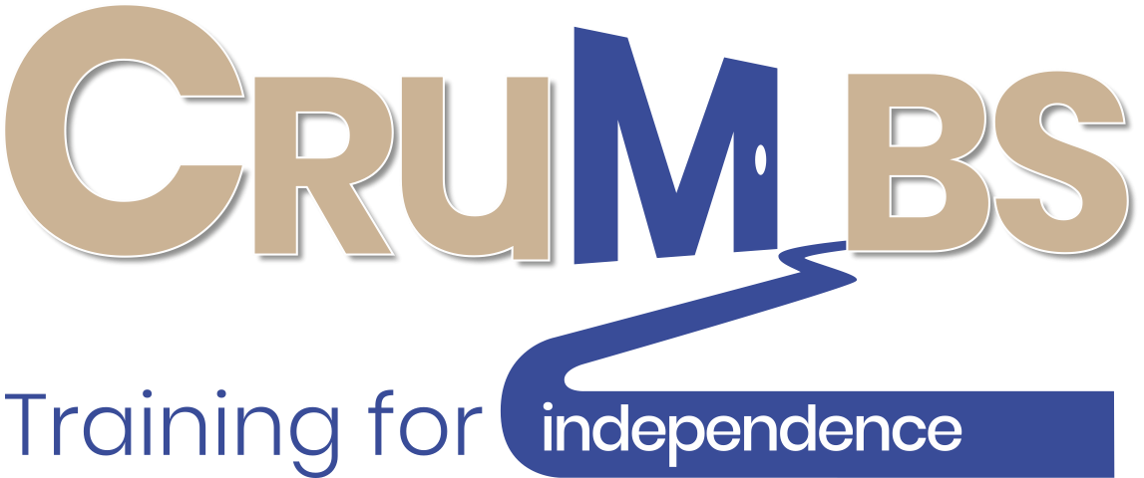
Pathway to Reopening
COVID GUIDELINES
April 2021 Version 3 ⎸
1
2
3
4
5
6
7

Pathway to Reopening
Step 1
All documentation developed, risk assessments carried out and mitigation measures in place.

Step 2
Crumbs Centre - operational protocols developed to take into account the physical distancing requirements, safe working practices, shift systems and revised working practices.

Step 3
Staff and volunteer briefings and discussions on returning to work arrangements including risk assessments and completing Covid -19 training. Staff and volunteers sign Return to Work forms.

Step 4
Advice sought from BCP on any special measures or guidelines relating to trainees, given the vulnerable nature of those trainees.

Step 5
Training video for trainees on the differences they will see on returning to training. Trainees complete online Covid-19 training. Trainees contacted, individual discussions and commitment including key workers on returning to professional training at the Centre.

Step 6
All documentation and systems in place and verified. Approval by the Board on reopening schedule.

Step 7
Gradual phased reintroduction of trainees

Contents

Introduction 4
Health & Safety 5
Working Practices 6
At the Centre 7
Cleaning Procedures 8
Food Production and Service 9
Professional Training 9
Further Information 10

Introduction

This guide highlights the actions that have been taken to ensure that the Crumbs Centre is a Covid-19 Secure Environment for all of the Crumbs Beneficiaries.
At Crumbs the trustees and staff are focussed on creating the best possible Covid - 19 compliant conditions, to ensure that all beneficiaries of Crumbs are in safe and secure environment and that our training and food service activities can continue and develop.
The Team has meticulously reviewed every detail and area of our operations to implement enhanced safeguards. Some of these changes will be self - evident while others will be less visible too many users. Nonetheless, all are important and will contribute collectively to a safe experience in how we deliver a good working environment for our trainees, staff and volunteers.

Professor Peter A Jones MBE
Chair

Health & Safety
To help protect all beneficiaries and as a condition of using the Centre all staff, volunteers and trainees will need to attest that they are, to the best of their knowledge, free of COVID - 19 symptoms and exposures. This will be undertaken prior to attendance by completion of a Return to Work Form.
At the entrance to the Centre, temperature screening systems will be used to aid the detection of elevated body temperatures as part of the plan to help protect all users. This includes every member of staff. The information which is observed is not stored, shared, or used for any other purpose. Users are not required to wear cloth face coverings but may choose to do so and masks are available on arrival. Signage will be posted to remind all users of Crumbs policies which will accord with the Government’s requirements.
Health Concerns. All staff have been trained on how to respond swiftly and report all potential cases of Covid - 19 to the Management Team, to coordinate the response.
Any alerted case of Covid - 19 affecting the Centre, will be communicated with the local Public Health Authority and follow their recommended actions.
Medical Services. In the event that any user expresses any Covid - 19 health related concerns they will be referred to the appropriate healthcare advice and local medical services.
Physical Distancing. Occupancy limits based on the physical distancing requirements are in place as are floor markings and reminder notices. These will be closely monitored and applied, with further training given in the distancing protocols if required.
Sanitising Resources. Hand sanitiser stations are available at the entrance and in all communal spaces, including changing facilities. Additional cleaning facilities are also available and to be used in particular at key areas and ‘touch’ points.
Signage. Visual reminders for health, hygiene and physical distancing practices are displayed throughout the Centre in all areas.
Staffing and Trainee Capacity. The Team have carefully assessed the necessary staffing requirement based on production levels and trainee requirements. The operational plans and shift systems have been designed to create staff and trainee ‘bubbles’ to reduce any potential areas of community transmission.

Working Practices
Hand Washing. Proper hygiene and frequent hand-washing are vital to combat the spread of Covid - 19. All trainees, staff and volunteers are instructed to wash their hands often with soap and water for at least 20 seconds, especially the kitchens, after using the toilet, blowing their nose, coughing, or sneezing; before and after eating, starting their shift, or having a break. Sanitising stations are available throughout the Centre.
Health Screenings. Staff are all advised if they have a temperature they are to stay home and not travel to work until the cause is confirmed. Upon arriving for work, all users will be screened daily for Covid - 19 symptoms and temperatures over 38°C. Anyone confirmed to have symptoms or a temperature over 38C will not be allowed to enter the Centre, until the cause is investigated.
Personal Protective Equipment (PPE). Appropriate PPE will be worn by all users dependent on their role and responsibilities, and in adherence with Government guidelines. Every user will be issued with two cloth face coverings to wear when travelling too and from the Centre, If they are required to use public transport. Crumbs will provide necessary items of PPE as required.
Physical Distancing. All users are reminded to take physical distancing measures whenever possible. This includes seating in all break and dining areas, offices, kitchen work spaces, store rooms and other high - traffic areas. Flexible work arrangements, such as remote work and staggered shift arrivals, are used to reduce user contacts.
Policies. Safe return to work guidance is provided to all users and will include flexible working and leave options, protocols for health screenings, personal hygiene and physical distancing requirements, property and workspace cleanliness standards, delivery and personal travel policies, and detailed steps for responding to presumed Covid - 19 cases.
Pre - Shift & Timekeeping. Daily pre - shift briefings will be conducted in areas that allow for appropriate physical distancing, and be used as reminders of the necessary safe working practices and updates on training and production requirements.
Shared Working Space. The use of shared spaces is reduced where possible through the practical physical distancing and revised work arrangements. All office and shared spaces will be cleaned and disinfected daily.
Shared Equipment. Shared equipment including kitchen and office equipment will be cleaned and disinfected before, during and after each shift, or anytime the equipment is transferred to a new user. Examples include work phones, keyboards, and shared kitchen tools and equipment.
Signage. Signage is displayed throughout work areas to remind all users of physical distancing requirements and personal hygiene practices, such as hand washing.
Training. All users including staff and trainees will continue to train in all enhanced health, hygiene, and distancing practices to ensure they are consistently followed. Staff are trained to recognise and report Covid - 19 symptoms and follow medical care and isolation procedures as recommended by the Government.

At the Centre
Pre - Arrival. Arrivals should be pre planned and notified in advance including providing an estimated arrival time to avoid over occupancy of the Centre and to be able to manage the process efficiently and safely. External visitors will not be allowed into the Centre unless the visit is pre arranged.
Arrival. Upon arrival at the Centre all users will need to maintain physical distancing when gaining access. This process will inevitably take longer than before, and some waiting may be outside of the Centre. Please be patient with the staff during the arrivals process, which will happen as quickly as possible.
Checking in at Reception Physical distancing markers, hand sanitisers and temperature control checks will be in operation on arrival. All users will be checked in against the shift rosters by a member of the management team. Pre- arranged visitors will be required to undertake the same procedures and provide contact details including phone numbers and email addresses.
Test, Track and Trace Should any member of staff, volunteer or trainee be required to self isolate either because they have tested positive, are member of the same household as someone who has developed symptoms or been contacted by the NHS and advised to self isolate must inform Crumbs as soon as possible. Crumbs will advise the relevant agencies including NHS Track and Trace of the incident using the incident log to be found in the Contingency Plan. In addition Crumbs will inform and advise the families or the adult care teams as appropriate and ensure that they are aware of their responsibilities and protocols if contacted by NHS Track and Trace.
Digital Transactions. Payments will be using the new contactless payments systems where possible.

Cleaning Procedures
Prior to Covid - 19, the Centre already employed extensive health, safety, and hygiene measures throughout. The Crumbs Contingency Plan specifies that for any reopening following closure for any reason, the Centre will undergo a comprehensive ‘deep clean’. A process that will be repeated periodically and particularly in the event of an outbreak that affects the Centre. The enhanced cleaning protocols and operational practices will continue, supplemented by additional systems and new technology for cleaning and disinfecting. These are as follows:
- Air Circulating Systems. There will be increased cleaning frequency of the extraction and ventilation systems. Increased ventilation flows will be maintained throughout the building.
- Cleaning Products. A variety of anti - microbial and surface disinfectants are already utilised throughout. In high touch and impact areas long lasting advanced anti - microbial products will be used as protection against Covid - 19.
- Communal spaces. The frequency of cleaning and disinfecting of all spaces will increase. The emphasis on high - traffic areas and touch points, such as office desks, toilets, door handles, bins, entrances, communal tables surfaces and seating. Furniture is arranged to allow for physical distancing
- Laundry. All items of laundry, including trainee and staff uniforms will continue to be washed at a high temperature using the in house facilities and in accordance with current guidelines. Uniforms will be changed daily.
- Toilet facilities. All facilities will be cleaned, disinfected and checked frequently. All users will be requested to clean the facilities after use.

Food Production and Service
The Centre had high food safety standards in place prior to Covid - 19, and these have now been enhanced in line with the current guidelines. However owing to the pandemic, the food offer to external customers and community groups has changed. Community and office buffet food options will cease while a range of bakery and other options are still available to the local cafes. The Hibberd Court Residents are offered a more restricted menu offer for collection only. The dining room is closed in accordance with the appropriate guidelines.

Professional Training
The trainees professional practical training that took place within the centre, during the period of the lockdown, had to be suspended. In view of the vulnerable nature of the trainees and the need to maintain a learning engagement a wide range of online tools have been used to maintain learning and encourage engagement. This online and digital engagement and learning has been particularly successful and will continue when the Centre is able to reopen. The more knowledge based aspects of the training will be delivered online not therefore requiring trainees physical attendance at the Centre for those elements. The use of Zoom as one of the digital tools allows for small group work, employability skills and one to one mentoring sessions.
The professional practical training essential as part of the professionally recognised training program has been reorganised and modified in view of the revised health and safety measures, the building capacity and the physical distancing requirements. This has led to revised standardised training sessions of 4-hour shift bubbles limiting the number of trainees who can operate safely to 4 in the food production areas and 2 in administration in each shift. This pattern will allow trainees to complete the training programme but will inevitably lead to an extension of the time required.
For further information see, C-19 Crumbs Training Protocols

Further Information
In developing the new policies, operating protocols and risk assessments the following documents have been used. These are stored on the Crumbs Sharepoint Folder and can be viewed or copies provided on request.
- Working safely during the coronavirus outbreak - short guide HSE publication 05/2020
- Keeping workers and customers safe during COVID-19 in restaurants, pubs, bars and takeaway services. COVID-19 secure guidance for employers, employees and the self- employed. Government Publication published 23 June 2020
- Risk control, assessment and management, Crumbs Publication, published 04/2020
- Crumbs Home Working Policy published 04/2020
- Crumbs Home Working Checklist published 04/2020
- Crumbs Returning to Work Business Adjustments Post Covid -19 published 05/2020
- Crumbs Covid -19 Risk Assessment 06/2020
- Crumbs Covid -19 Operational Statements
- Crumbs Post Covid - 19 Training Protocols published 07/2020
- Helping day centres to ‘unlock lockdown’, part 1/2 July 2020
- Youtube Video Link: https://youtu.be/ltRr5h4AdEs

